THE EMOTION CYCLE
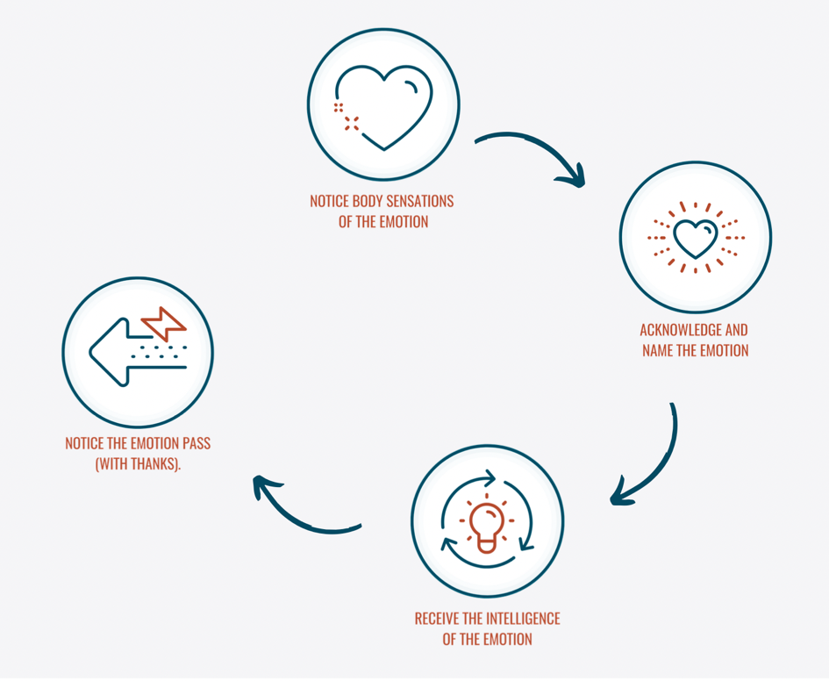
- Notice sensations of the emotion: | - Allow yourself to slowly scan your body - pay attention to where you are experiencing sensation in your body.  - Notice if the sensation is moving, or if it's static; notice if there is temperature to it; is there a colour you associate with this sensation?  - If you could reach inside your body and touch this sensation, what do you imagine it would feel like?
- Acknowledge and identify the emotion: | - Notice yourself feeling activated - this might be instant, or it may take some time to notice.  - Be curious and see if you can name what you are feeling (use the feelings wheel to practice this).
- Receive the intelligence of the emotion: | - What do you make this emotion mean?  - What is the emotion saying? What do you make this mean? Be curious – you can even ask it ‘sadness, what are you saying?’.  - Our memories are stored in the body so your emotions may offer a message from a different experience, or from a much younger age. Remember: you don't have to act on anything.
- Notice the emotion pass: | - When you have some information, you can let it go – you may want to shake your hands or rub them together and then ‘throw’ the emotion on the floor.  - Within around 90 seconds, emotions shift and change and you will settle back into a peaceful state.  - You may want to thank the emotion for the message – this can help to build a sense of usefulness for even difficult feelings.
Aftercare: | - Do you want to express something in some way? Do you need to communicate your needs?  - By taking the time to name and experience your emotion, you will have a greater chance of experiencing the clarity and power your emotions offer.  - This means how you respond, what you say and do before, during and after conflict comes from a place of peace. It means the experience is more likely to be about advocating for what matters to you.

